Music Department Activities
Spring Term 2025
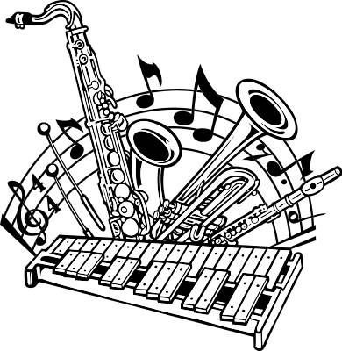
Day/Time | Lunchtime (12.40 – 1.05pm) |  | After School (3-4pm)
Monday | Flute Choir (all years) - Mu 2  Soul Band (all Years) - Mu1 |  | Concert Band (all years) - Mu 1
Tuesday | String Ensemble (all years) - Mu 1  Music Theory Support drop - Mu 3
Wednesday | Woodwind Ensemble (all years) - Mu 1  Snare Drum Group (all years) – Mu 2 |  | Orchestra (all years) - Mu 1
Thursday | Upper School Choir (years 9+) - Mu 1  Brass Ensemble (all years) - Mu 2
Friday | Comberton Young Voices (Yrs 7-9) Mu 1 |  | Big Band (all years) - Mu 1
All students participating in any of the above clubs are asked to contribute towards running costs. £10 per child or £12 per family for unlimited music clubs per term, payable via ParentPay. Please click on the activity name to complete the registration form before attending as spaces maybe limited.
Any queries, please speak to a member of staff in Music Department. Look out for new clubs starting soon!

